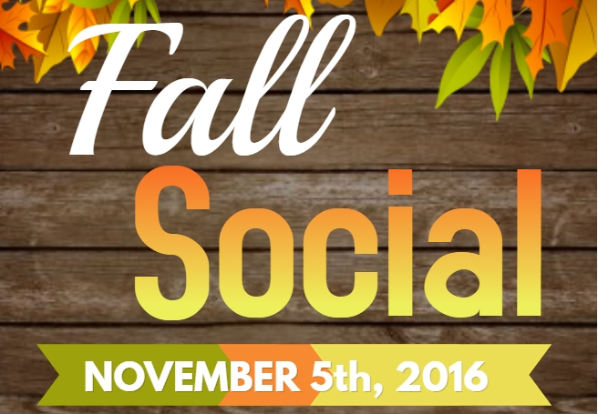
2016 Fall Social Fundraiser Ticket Order Form

$20 ticket includes a $20 Gift Card which may be used to order any item from the menu

Additional $20 Gift Cards may be purchased to cover the remainder of your bill

All Gift Cards purchased through the school will directly benefit St.Bernadette Elementary

Gift Cards will not available for purchase on the night of the event. Gift Cards do not expire. Any unused portion of your Gift Card may be used for future visits at the One20 Pub

Each $20 Gift Card = One entry in door prize draw. This is an adults only event (19 years or older).

Example:

Stuart and Stephannie purchase 2 tickets ($20/ticket x 2 = $40). They anticipate the cost of dinner/drinks to be around $60. They purchase an additional gift card ($20 Gift Card x 1 = $20).
Total of 3 Gift Cards ($60) = 3 entries in to the door prize draw

Cut _ _ _ _ _ _ _ _ _ _ _ _ _ _ _ _ _ _ _ _ _ _ _ _ _ _ _ _ _ _ _ _ _ _ _ _ _ _ _ _ _ _ _ _ _ _ _ _ _ _ _

2016 Fall Social Fundraiser Ticket Order Form

_______ # of tickets ($20/ticket. Minimum of 1 ticket per person)

_______ # of additional Gift Cards ($20 each)

$______ Total amount

Name:_______________________________________________

Ticket deadline Friday October 28th/16.

For more information or questions please contact fundraising@stbernadette.ca

