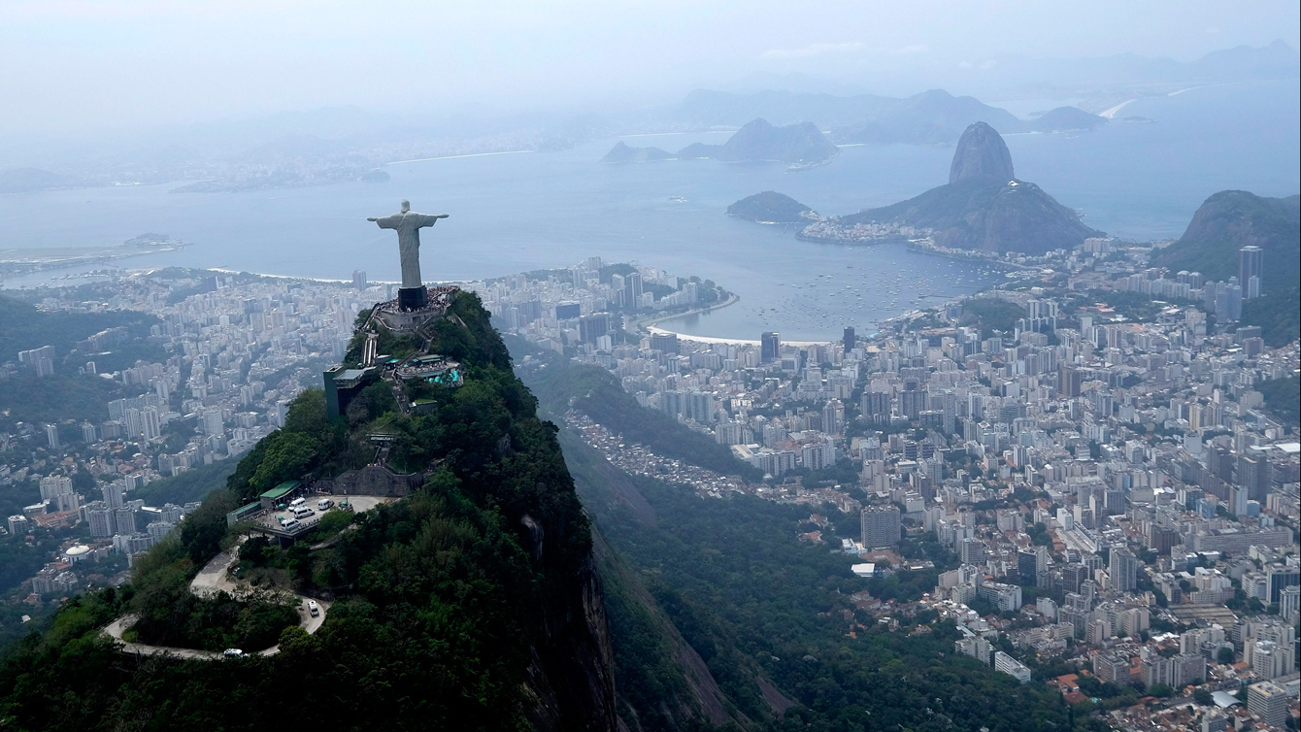

St.Bee’s Rio Olympics 2016

Friday, June 10

This year’s theme for Fun day on Friday, June 10 is St. Bee Rio Olympics 2016. Students will be making Country posters during the June 6 Assembly. Your son/daughter will be choosing a colour on that day with his/her family group that he/she will wear on Fun Day. We invite you to come out and enjoy the Fun Day festivities on June 10th!

FUN DAY SCHEDULE

Prayer and Attendance in Classrooms

9:15
- Meet with Family Groups
- Come to the gym - bring skipping rope with flag poster and score sheet
- Sing O Canada
- Grade 7’s head to their stations

9:30 -11:15
- Rio Stations begin
- Score sheets must be brought to each station

11:15 – 11:45
- Hot Lunch in classrooms

11:45 – 12:15 (Top Field)
- Finalists Ceremony
- Toddler & class races
- Grade 7 Balloon Toss
- Students are dismissed from their classroom at the end of the events

